Amazon DynamoDB
- Amazon DynamoDB is a fully managed NoSQL database service that offers fast, predictable performance and automatic scalability.
- AWS handles all operational tasks — hardware provisioning, setup, replication, patching, and scaling — so you can focus on your application.
Key Capabilities:
- Create tables that can store and retrieve any amount of data and handle any level of request traffic.
- Scale throughput capacity up or down without downtime or performance loss.
- Monitor performance and usage through the AWS Management Console.
- Automatic data distribution across multiple servers to meet storage and throughput needs.
- Data stored on SSDs and replicated across multiple Availability Zones, ensuring high availability and durability.
Core Components:
- Table: A collection of items.
- Item: A single record in a table (like a row in relational databases).
- Attribute: A data field within an item (like a column).
- Primary keys: Uniquely identify each item.
- Secondary indexes: Provide flexible and efficient query options.
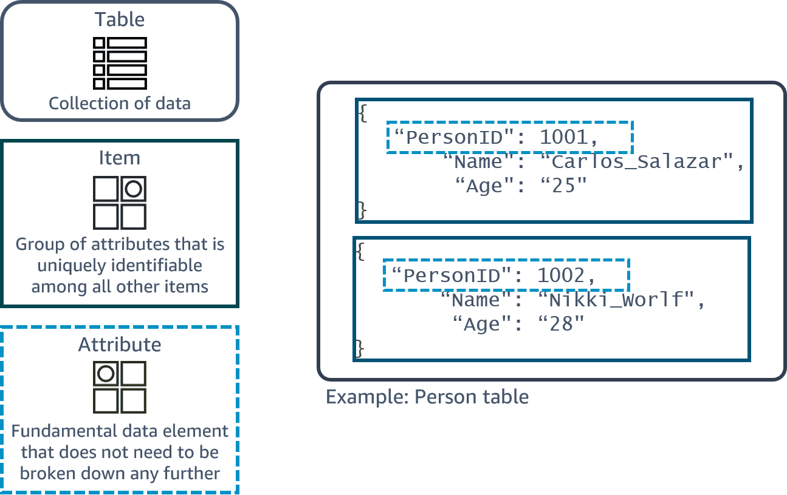

DynamoDB security
- Amazon DynamoDB offers a highly durable storage infrastructure for mission-critical and primary data.
- Data durability: Information is redundantly stored across multiple devices and facilities within a Region.
- Encryption: All data is fully encrypted at rest using AWS Key Management Service (KMS) for enhanced security.
- Access control: IAM (Identity and Access Management) is used to authenticate, authorize, and manage permissions for DynamoDB resources.
- Managed security: DynamoDB benefits from AWS’s global network security protections as part of its managed service model.

